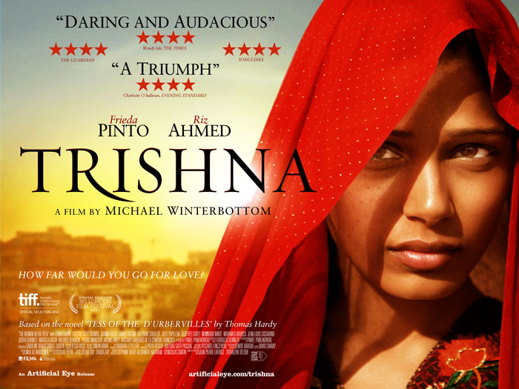

Teachers’ Notes
This study guide exploring Michael Winterbottom’s film Trishna is suitable for English Literature students and can also be used with students of Film and Media Studies at AS/A2 Level and equivalent. Activities here are supported by the film’s trailer online at: www.filmeducation.org/trishna

Based on Thomas Hardy’s classic novel Tess of the D’Urbervilles, Trishna is a beautifully shot, classic tale of love and tragedy set across modern-day rural Rajasthan and the thriving metropolis of Mumbai.

Student Activities
Based on a classic
Read the following synopsis for Trishna and the extracts from the production notes below, explaining how and where director Michael Winterbottom made certain changes to the original story. After reading, discuss the questions that follow the extracts.

Long synopsis
Trishna is a contemporary love story, based on Thomas Hardy’s classic novel Tess of the D’Urbervilles. Set in a rapidly changing modern-day India, the complexities of love are played out against a backdrop of the conflicting pressures of traditional rural society and the rise of the middle class, as industrialisation, urbanisation and education alter the fabric of society. Trishna is the beautiful, yet tragic story of one woman whose life is destroyed by love and circumstance.

Trishna (Freida Pinto) is taking part in a traditional dance evening at a hotel close to her rural village, when she meets Jay Singh (Riz Ahmed) a wealthy young British businessman, who is enjoying one last holiday with his friends before he reluctantly takes over the responsibility of his father's newly acquired hotel business in Rajasthan. Jay is immediately captivated by Trishna, to him she represents all that is pure and she’s a symbol of reconnecting with his roots in India. When his friends leave for England, Jay seeks her out. He finds her after an accident has destroyed her father's Jeep, the family’s main source of income. Jay suggests that Trishna comes to work at his father’s hotel in Rajasthan and after he leaves, he sends for her.

Trishna adapts well to her new life and Jay’s growing love for her becomes apparent – he even encourages her to join a hotel management course at a local college. When Jay rescues Trishna from the unwelcome attention of a group of local young men following her college friend’s wedding, the electricity between the two is overwhelming and Jay takes them on a detour on the way back to the hotel and they make love, for the first time, in a deserted rural spot. In the early light, Trishna wakes at her shared lodging and feels shamed by her behaviour and quickly packs her few belongings and heads back to her family.

The months pass and Trishna is working in the fields with the other women from her village when, one morning, she starts to feel violently sick. Her parents take her to a doctor and, after three missed periods, it becomes apparent that she’s pregnant with Jay’s child. Her father quickly arranges an abortion. Despite removing the problem, her father is aware that people are talking in their
tight-knit community, so Trishna is packed off to help an ailing elderly aunt. After working all day in a factory and caring for her aunt at night, Trishna is miserable and exhausted, she misses her family and thoughts of Jay are never far from her mind. Jay manages to track her down. He asks her to come and live with him in Mumbai, where he now lives, and the young lovers leave that night.

Their new life together in a beachside apartment in Mumbai is a far cry from anything Trishna has ever experienced. Jay’s friends are sophisticated, wealthy and educated and he soon gets involved in financing Bollywood films. He lavishes new dresses on Trishna and she embraces the party lifestyle and even shows flair as a Bollywood dancer.

When Jay gets a call from England to say his father is sick, he prepares to fly home, having promised Trishna he’s going to tell his family about their relationship. But, the night before he leaves Trishna drops a bombshell – she tells him about the abortion. He’s furious and frustrated to learn she’s kept this from him for so long. In the morning, he’s cold with her and quickly leaves to catch his flight.

The weeks pass and Trishna busies herself with friends and dance classes, but is sad there has been no word from Jay. One morning, a letting agent arrives at the apartment and tells Trishna that she has to leave as the lease is up. Hurt, yet uncomplaining, Trishna moves in with some girlfriends. When Jay finally returns, they pick up the relationship and he tells her he has to go back to Rajasthan to sort out affairs at his father’s hotel and that she can go with him but they won’t be able to live as a couple as they have been in Mumbai.

Cracks start to appear in the relationship in Rajasthan as Jay’s mood darkens and his frustration escalates at being forced back to run the hotel. Trishna becomes little more than his slave as he continually projects his own failure and disappointment onto her. Their clash of cultures collide dramatically and Trishna is finally provoked into an act that will have tragic consequences for both of them.

Extract from production notes:

Interview with Trishna director Michael Winterbottom

Q: What were the big changes you made to the story?
A: Well the biggest I guess was in combining two characters into one. In Tess there are Angel and Alec, the spiritual versus the sensual. I think most people are a combination of both. And having worked with Riz before I thought he was capable of bringing out that complexity in Jay. He does fall in love with Trishna, but he is rich and young and wants immediate gratification. If he stood back, he would realise that the consequences for Trishna of what he does would be huge, whereas he, as a man, and as a rich man, can get away with whatever he likes.

Then in terms of context – besides mobility and education and urbanisation Trishna is also set in a world where international tourism has a big impact. Tourism is a big industry in Rajasthan. It has contradictory effects. It provides opportunities for work and careers. The other characters in our film who work in the hotels – Rita, Chanchal and Manisha are played by people who do work in tourism. They are young, college-educated articulate women who hope to have a good career. But tourism also recreates a sort of neo- colonialism where rich westerners can live in palaces and be waited on hand and foot.

This has an echo in the original story. Alec D’Urberville is the son of a factory owner from the north of England who has come south and bought an old manor house and is pretending to be aristocratic. Jay’s father has done the same. Having made his money in property in England, he has returned to India to buy up some of his country’s heritage. Jay, like Alec, is the son who has had it too easy. He’s been spoilt by not having to work or to make his own way in the world. Trishna is the opposite. She has the burden not only of looking after herself, but also her family.

Another change is that in Hardy’s story Tess gives birth to a child, who dies. Researching in Rajasthan, everyone told us that if an unmarried girl got pregnant the family would want to try and get an abortion before any other people became aware that she was pregnant.

For discussion
From reading the synopsis and interview extracts from the production notes, what are the main parallels you can identify between Trishna and Hardy’s novel? Think in particular about:

- characters
- plot
- setting
- themes

To what extent does what you have read here fit with your interpretation of and response to the novel?

Exploring Images
Relationships
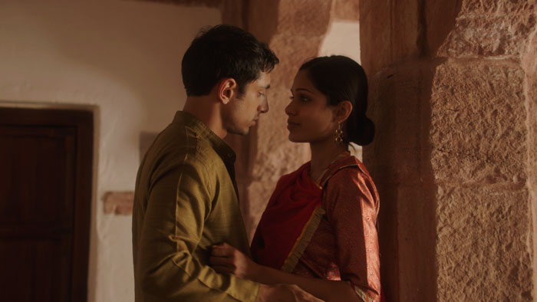
Image 1
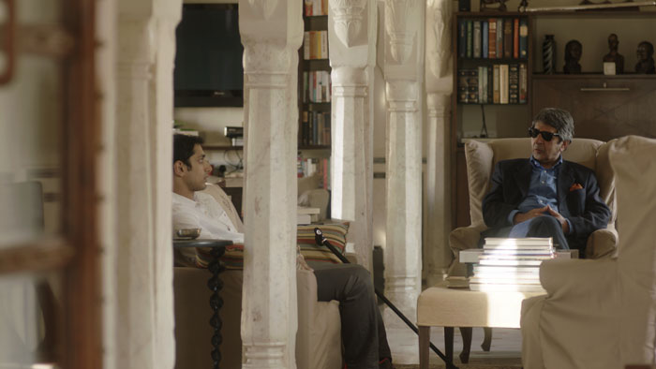
Image 2
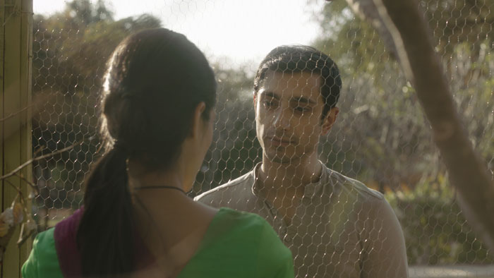
Image 3

- How do the shot composition and mise en scéne, as well as the gesture, posture and expression of the actors, encourage the viewer to respond to the characters in these images?

- Romantic love and family duty are themes in both Trishna and Tess of the D’Urbervilles. What do these images suggest about the director’s treatment of these themes and how does this treatment compare to Hardy’s?

- In Tess of the D’Urbervilles, Hardy challenges his society’s attitudes towards romantic relationships between men and women. From what you know of Trishna and with reference to Image 3, to what extent do you think director Michael Winterbottom has a similar intention?

Class
Social class and status are central to both Trishna and Tess of the D’Urbervilles. What do these images below suggest about how the question of status and class might be treated in the film? Look closely at shot composition, mise en scéne, characters’ posture, gesture and facial expression.
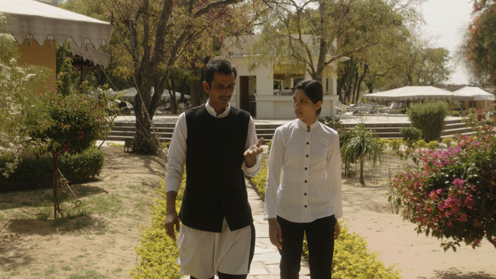
Image 4

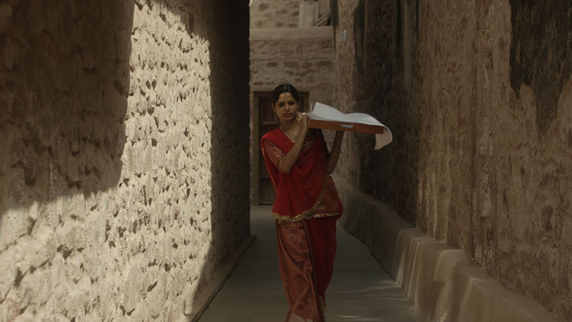
Image 5
The Trailer
Watch the trailer on the website, www.filmeducation.org/trishna then discuss these questions.

- Director Michael Winterbottom states that Trishna is not a Bollywood film although he says it has “one foot in Bollywood”. What elements of the trailer are typical of the Bollywood genre and what elements make it feel like a British film?

- Like Hardy, Winterbottom is keen to provide a context for his protagonist’s story. How does the trailer create this context?

- What does the trailer suggest about the film’s representation of class and gender inequality?

Interpretation
In this extract from the production notes, the director describes the heroine of Hardy’s novel as being ‘enigmatic’, a quality he tries to replicate in his own version of the story:

‘…in Hardy’s story it is important that you don’t know exactly what she is feeling or thinking. There is an opaque quality, an enigmatic quality. I think Freida [Pinto] pulls this off very well. So we have to guess what is going on in her head. And sometimes to be frustrated by her passivity.’

Now read this short extract from the novel. After reading, discuss with a partner if you agree with the director’s description here of Tess as an enigmatic, passive character:

Her face had latterly changed with changing states of mind, continually fluctuating between beauty and ordinariness, according as the thoughts were gay or grave. One day she was pink and flawless; another pale and tragical. When she was pink she was feeling less than when pale; her more perfect beauty accorded with her less elevated mood; her more intense mood with her less perfect beauty. It was her best face physically that was now set against the south wind.

Tess of the D’Urbervilles (1891) by Thomas Hardy
Phase the Third, Chapter 16

After Viewing
After you have seen the film, discuss the following statements explaining the extent to which you agree or disagree. Wherever possible, try to support your ideas with evidence from both the novel and the film.

- Trishna and Tess are responsible for their own suffering.

- Both Trishna and Tess of the D’Urbervilles are stories about the exploitation of women.

- In Tess of the D’Urbervilles, Hardy clearly had an interest in the concept and power of fate: “She had hoped to be a teacher at the school, but the fates seemed to decide otherwise.” (Phase the First, Chapter 6) Winterbottom’s characters, by contrast, are more in control of their own destiny.

